:e edge cases,to move two piecesd**Test Manual**

1. Hit “Play” button for Main Class, and we are taking manual test case for the Game loop.

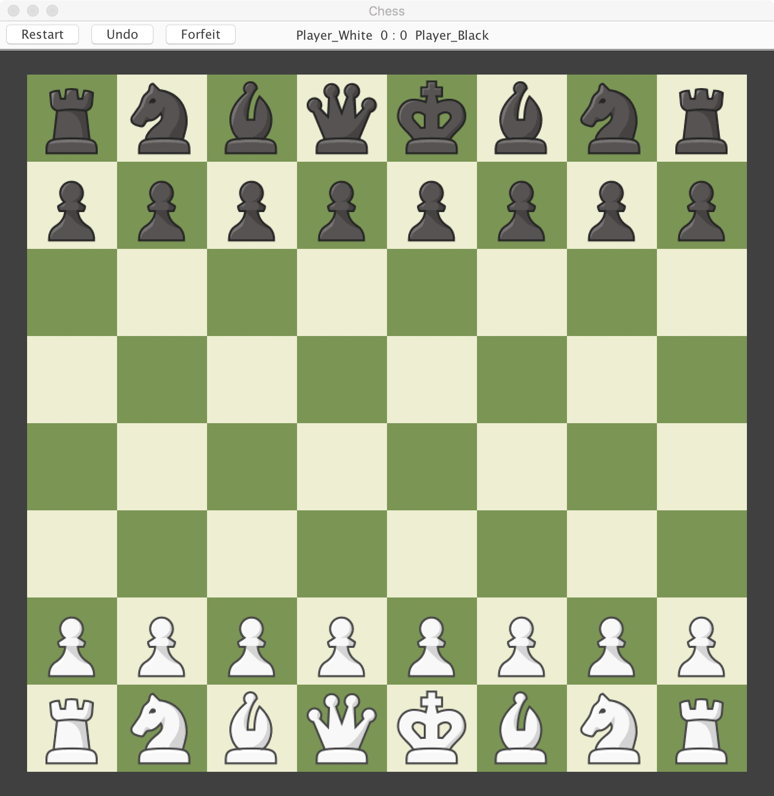

1. **Test for Check Mate:** Move White Pawn two steps forward, and do the same for Black Pawn. Move your White Bishop and then Black Bishop diagonally as shown. Select White Queen and use Black Knight for a Block. Move your White Queen to kill the Black Pawn. The Black King should be in Check Mate and we get this dialogue box as an end game signal. Total score should be shown as below.

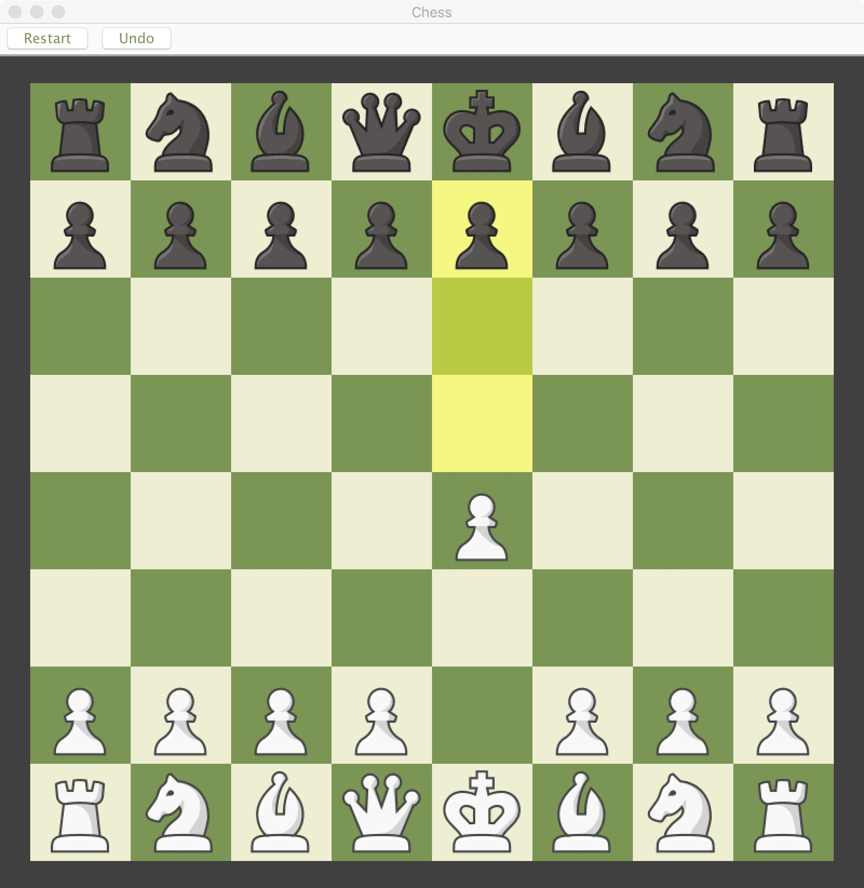 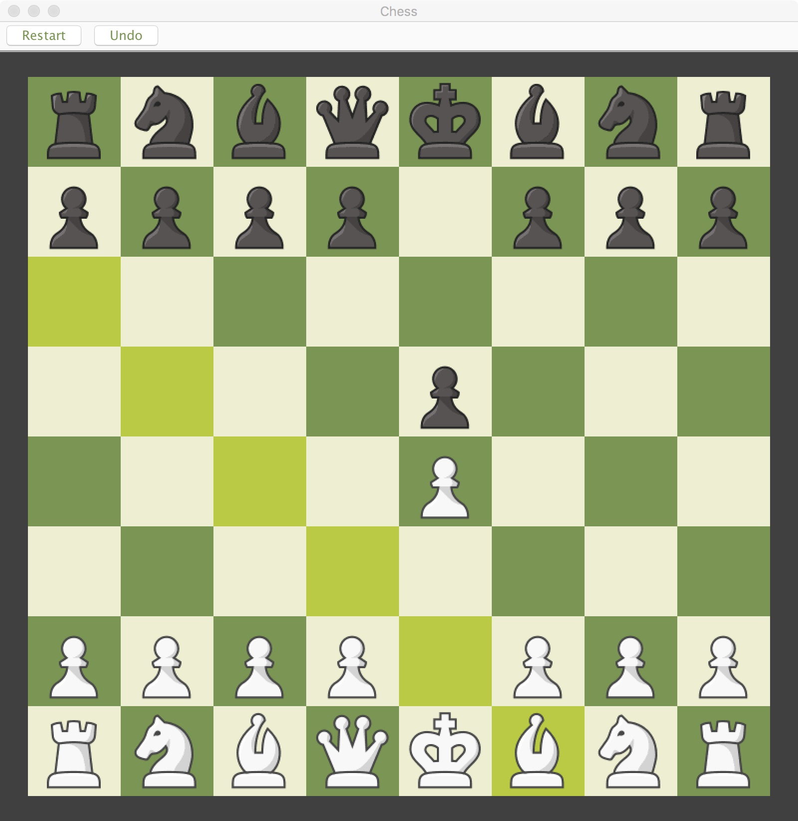

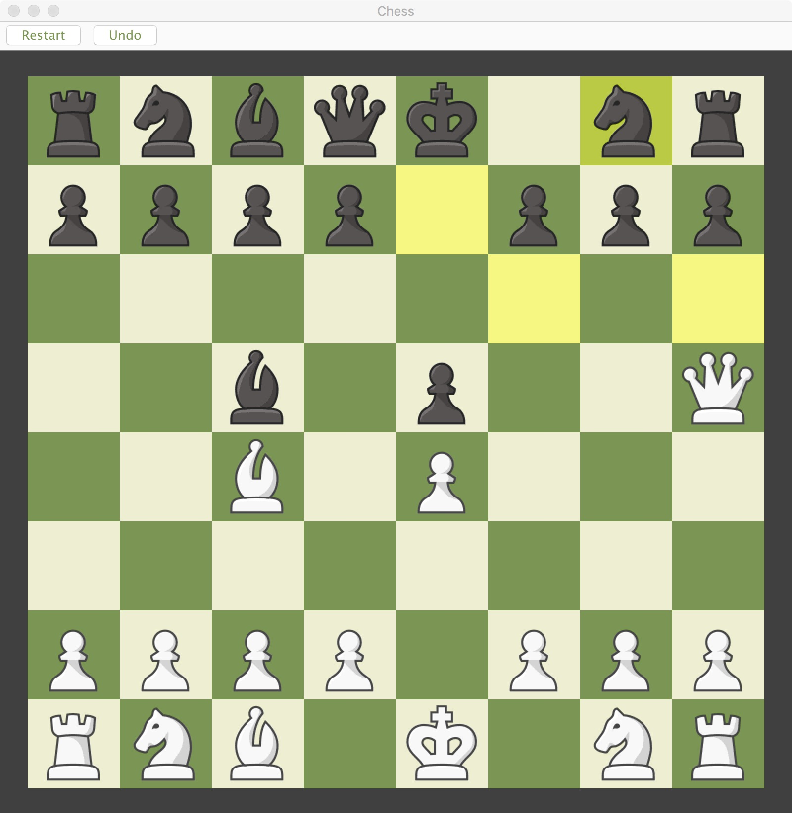 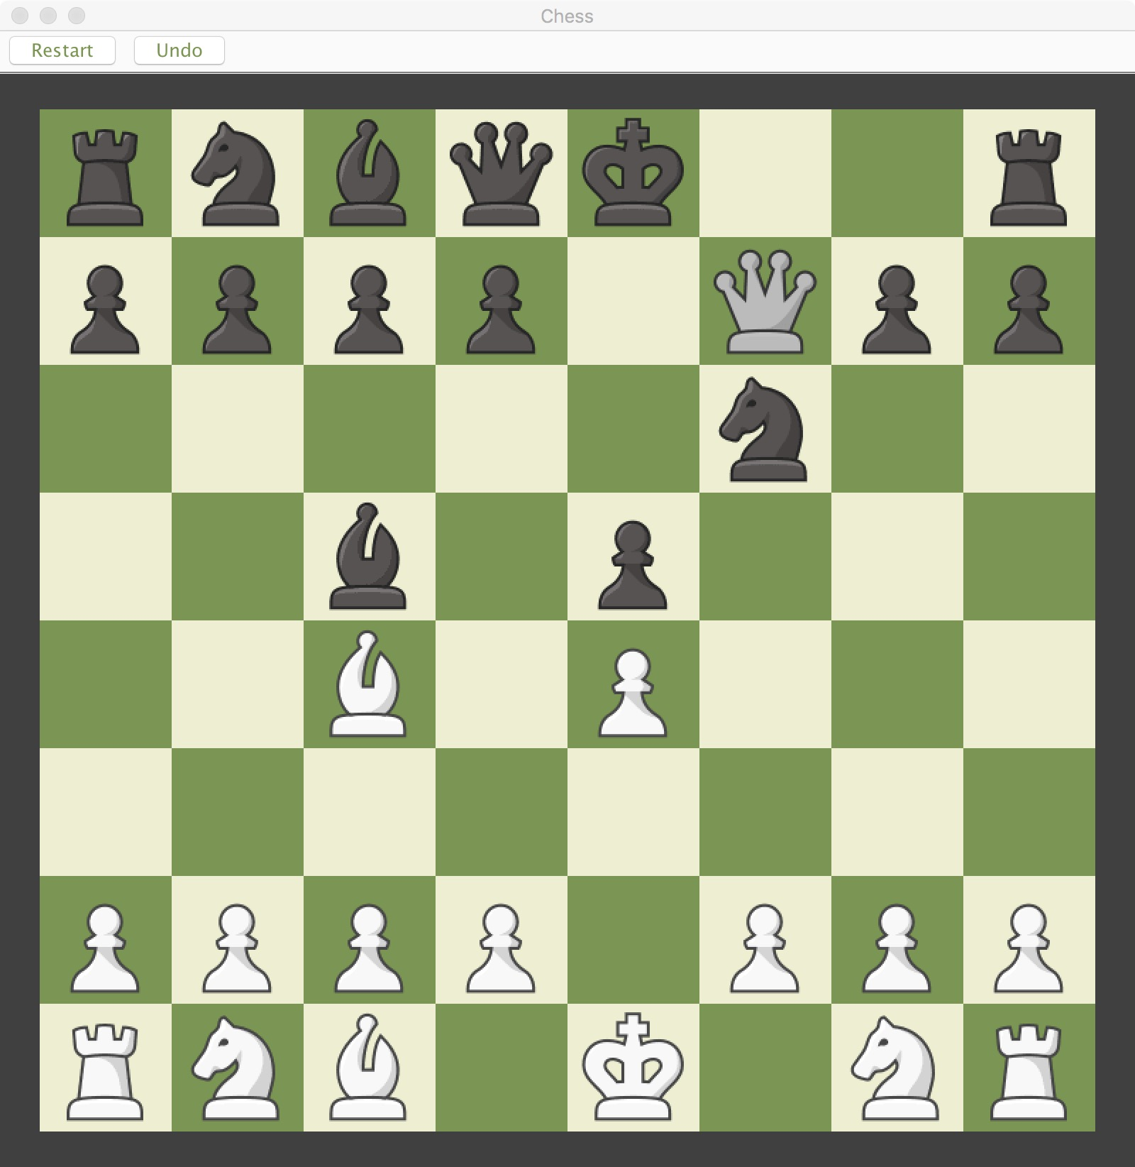

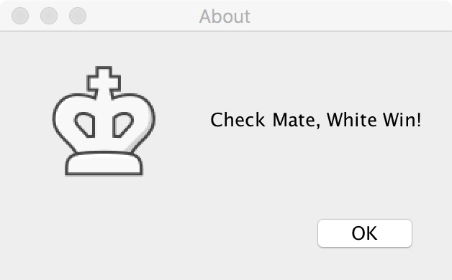 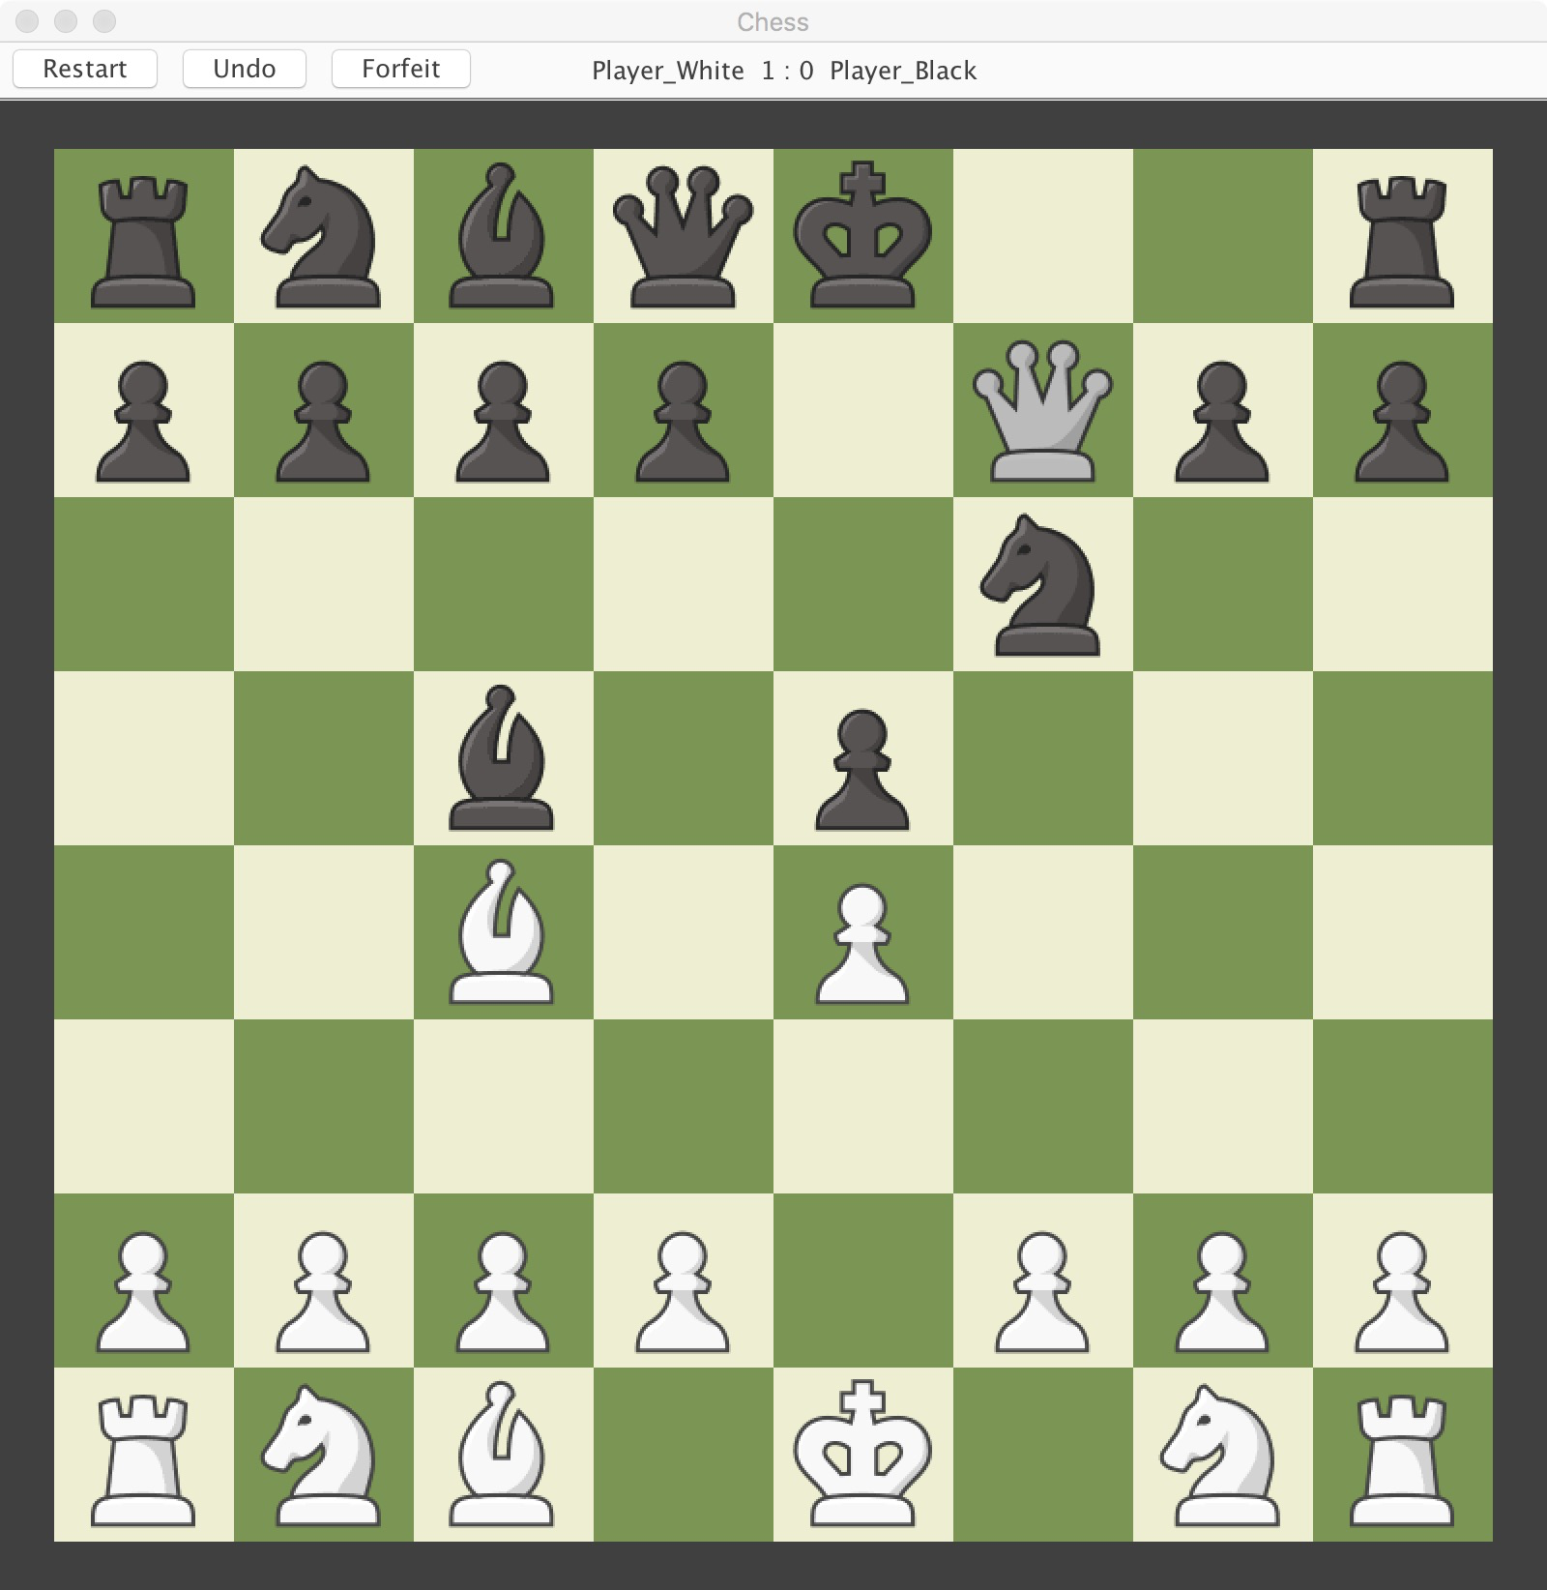

1. **Test for Restart:** Move any pieces for some steps, and hit “Restart” button.

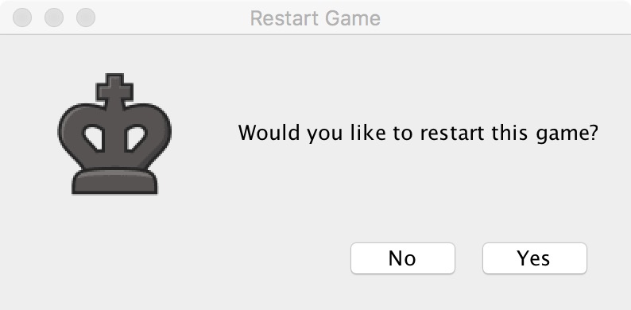 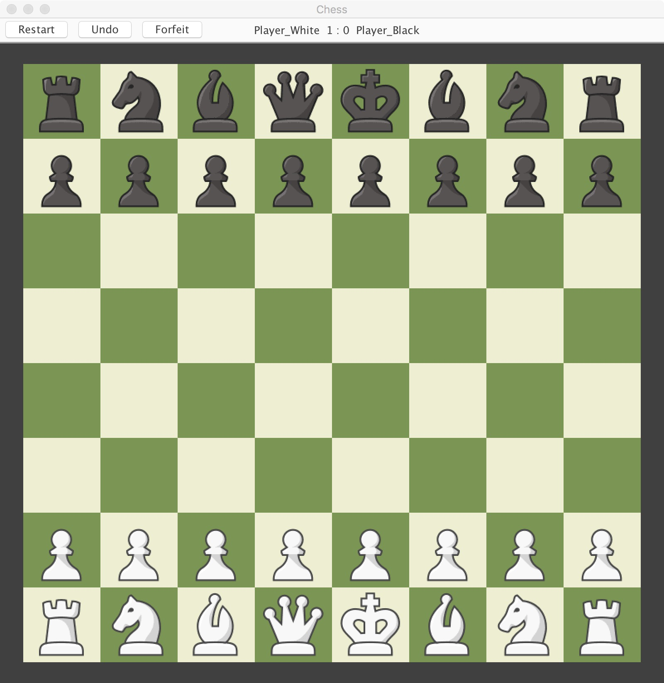

1. **Test for Undo:** Move any pieces for some steps, and hit “Undo” button. You should be getting the following warning at Check-King state. Test for the Pawn’s first move edge cases: if Undo, the Pawn should still be able to move two pieces ahead.

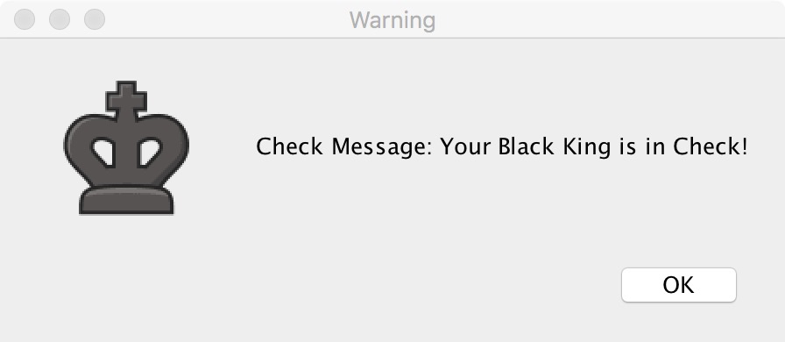 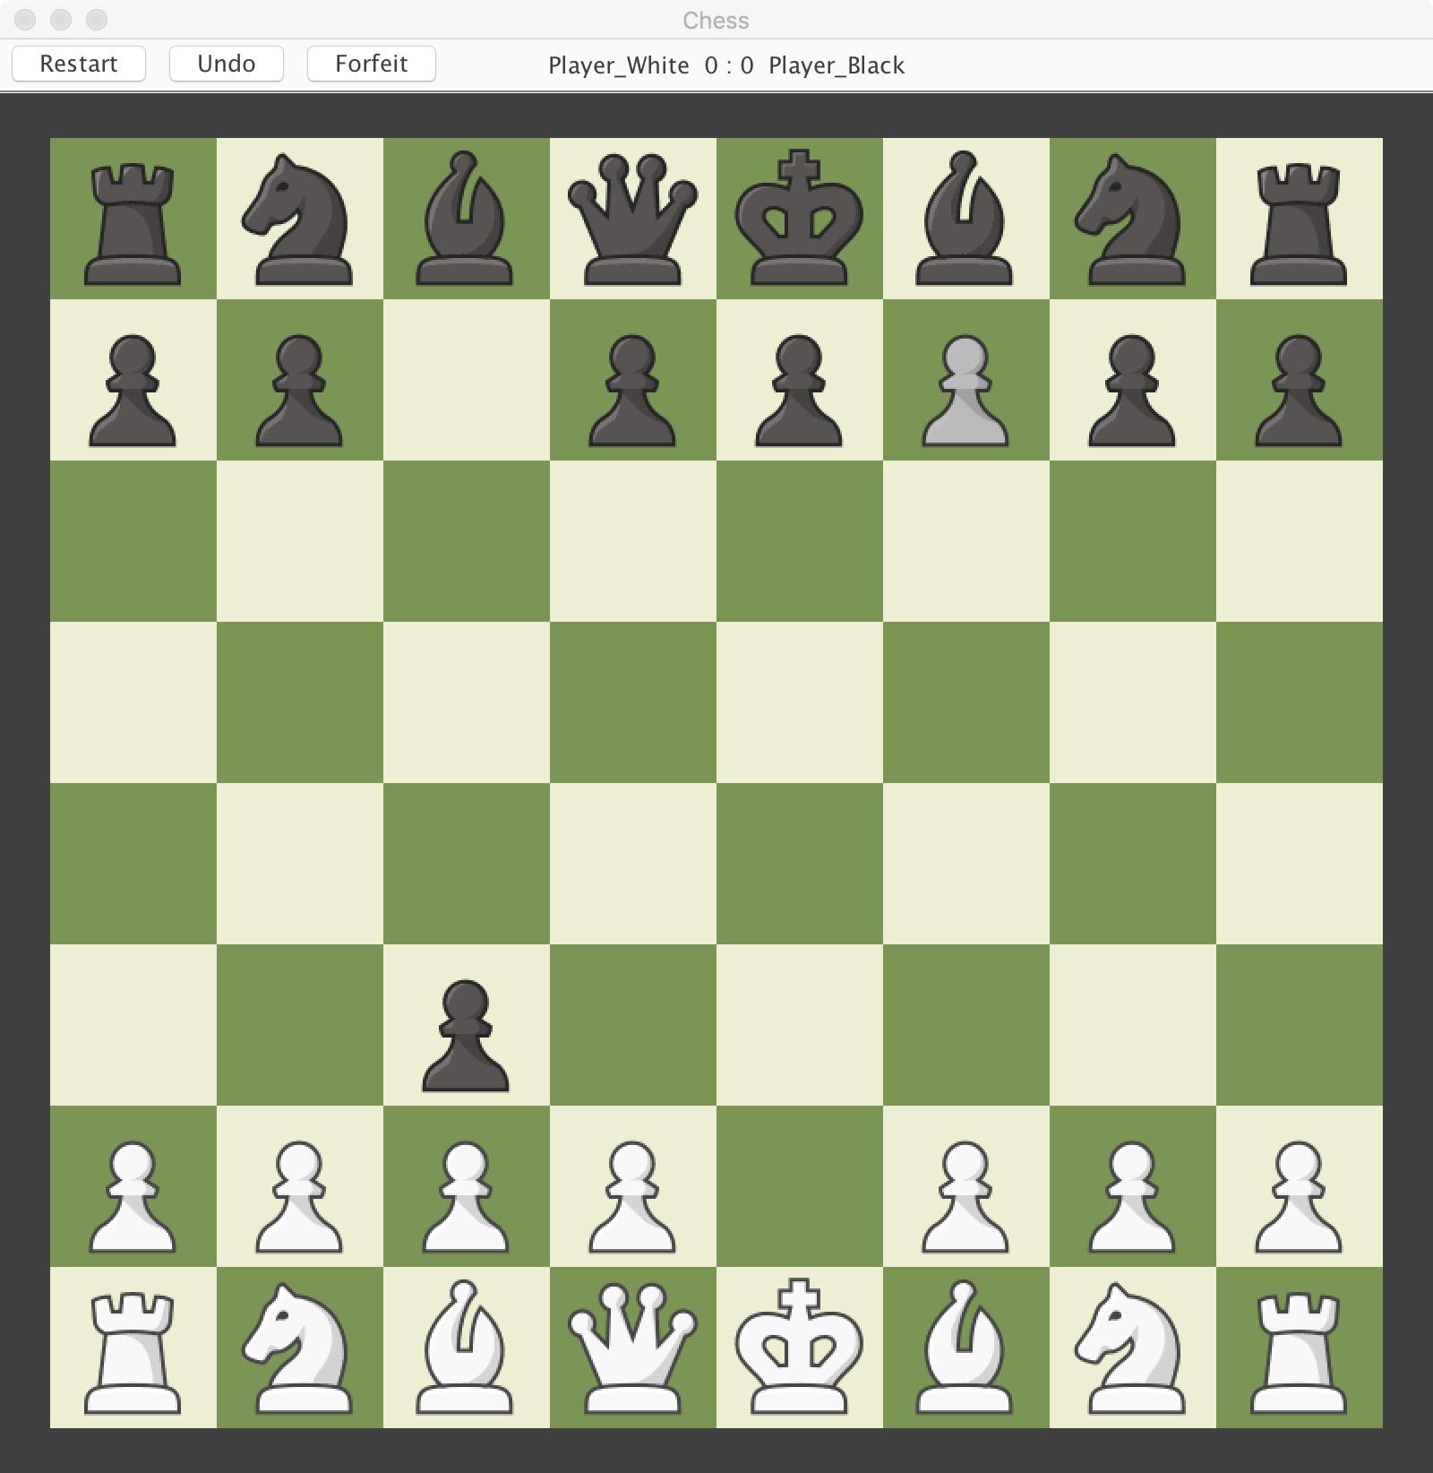

1. **Test for Forfeit:** Move any pieces for some steps, and hit “Forfeit” button. If it is the Player Black for winning, we can see a black king icon. On the other way around, we can see a white king icon. The scoreboard should be adding 1 point for the winning player.

